

3.7: Defining Functions in Python (Hello World Function) Walkthrough

Functions are a block of code which allows us to break up our programs into smaller, more manageable chunks. These functions must perform a single, specific task. For this example, we are going to write a function which prints “Hello, World!” to the console.

When we are writing functions, we use the def keyword. Once you have named the function and put two brackets (()), you will need to have a colon (:). Combined, the def, (), and : are the function definition. In Python, tabs are very important – they are used to define the commands which are contained within the function (and for other Python constructs, which we will discuss later).

Let’s define our say_hello_world() function. In your Python file, enter the following code:

def say_hello_world():

print("Hello, World!")

This has now defined your say_hello_world() function. However, if we simply run this file, the say_hello_world() function will not do anything:

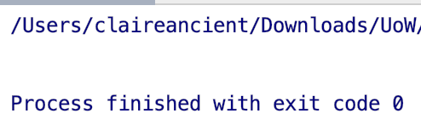

The function will only run when it has been called. To call the function we use the following code:

say_hello_world()

Enter the line above in your Python file, but make sure that there is no tab. The below screenshot shows how it should look:

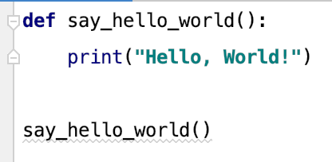

Now when you run your file, you should get the following output:

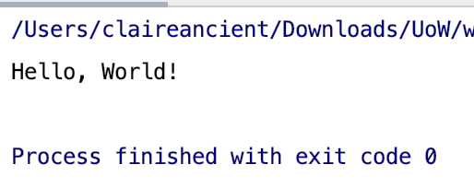

The benefit of using a function is that we can run the same function repeatedly and the process will be followed every time:

